**8 BIT MULTIPLICATION:**

**CODE:**

LDA 2001

MOV B,A

LDA 2005

MOV C,A

MOV A,B

MVI B,00

LOOP: INR B

SUB C

JNZ LOOP

MOV A,B

STA 2010

HLT

**OUTPUT:**

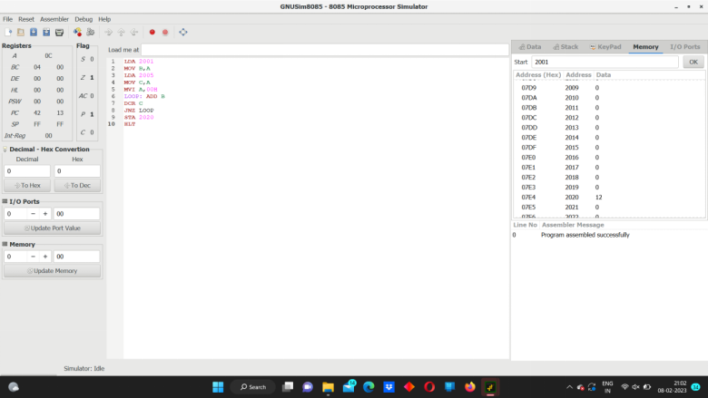sss